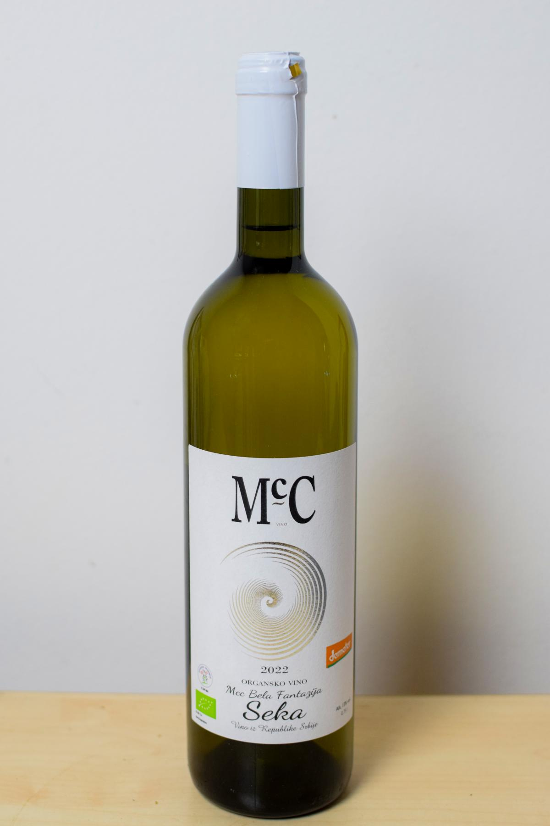
Qwwdq

Bela Fantazija Seka
- Dry white wine- -

About the vine

Grape varieties:
- Rajnski Riesling,
- Sauvignon Blanc,
- Traminac

Origin: Erdevik, Fruška Gora
Temperatura serviranja:10-12 ºC

A blend of three grape varieties dominated by Rhine Riesling (70%), Sauvignon Blanc (20%), and Traminer (10%). The aroma is led by floral notes complemented by hints of dried fruit. On the palate, it is full-bodied, harmonious, and elegantly rounded with a long-lasting finish. It pairs perfectly with grilled fish, risotto, and white meats, especially turkey.

Award
2024 – Winner of the Bronze Medal at Wine Vision by Open Balkan 2024 for the wine “Bela Fantazija Seka 2022”.

